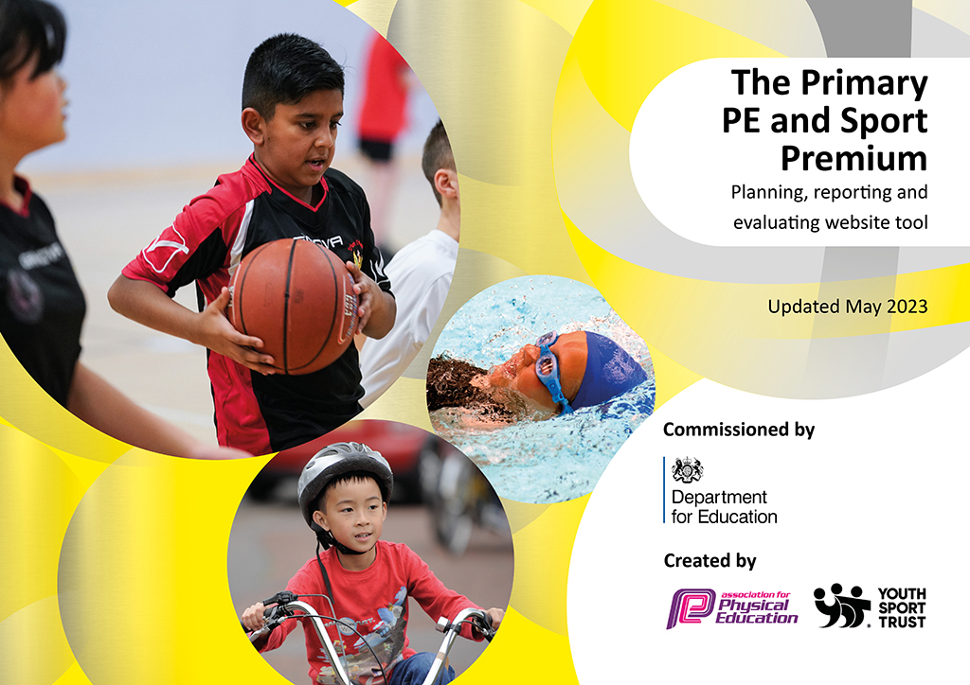
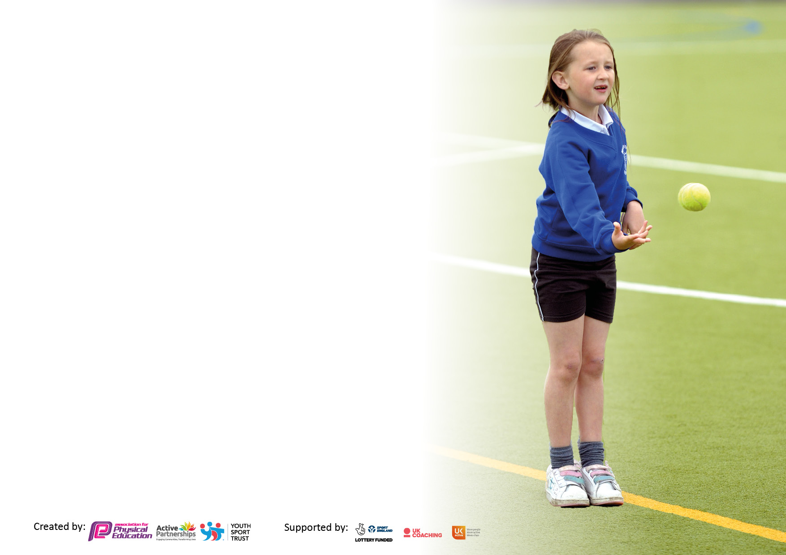

It is important that your grant is used effectively and based on school need. The Education Inspection Framework makes clear there will be a focus on ‘whether leaders and those responsible for governors all understand their respective roles and perform these in a way that enhances the effectiveness of the school’.

Under the Quality of Education Ofsted inspectors consider:
Intent - Curriculum design, coverage and appropriateness
Implementation - Curriculum delivery, Teaching (pedagogy) and Assessment
Impact - Attainment and progress

To assist schools with common transferable language this template has been developed to utilise the same three headings which should make your plans easily transferable between working documents.

Schools must use the funding to make additional and sustainable improvements to the quality of Physical Education, School Sport and Physical Activity (PESSPA) they offer. This means that you should use the Primary PE and sport premium to:

- Develop or add to the PESSPA activities that your school already offer
- Build capacity and capability within the school to ensure that improvements made now will benefit pupils joining the school in future years
- The Primary PE and sport premium should not be used to fund capital spend projects; the school’s budget should fund these.

Pleasevisitgov.ukfortherevisedDfEguidanceincludingthe5keyindicatorsacrosswhichschoolsshoulddemonstrate animprovement.Thisdocumentwillhelpyoutoreviewyourprovisionandtoreportyourspend.DfEencouragesschools to use this template as an effective way of meeting the reporting requirements of the Primary PE and Sport Premium.

We recommend you start by reflecting on the impact of current provision and reviewing the previous spend.

Schools are required to publish details of how they spend this funding, including any under-spend from 2021/2022, as well as on the impact it has on pupils’ PE and sport participation and attainment. All funding must be spent by 31st July 2023.

We recommend regularly updating the table and publishing it on your website throughout the year. This evidences your ongoing self-evaluation of how you are using the funding to secure maximum, sustainable impact. Final copy must be posted on your website by the end of the academic year and no later than the 31st July 2023. To see an example of how to complete the table please click HERE.

Details with regard to funding
Please complete the table below.

Total amount carried over from 2021/22 | £7372.40
Total amount allocated for 2022/2023 | £18,040
How much (if any) do you intend to carry over from this total fund into 2022/23? | £1167.25
Total amount allocated for 2023/24 | £18,020
Total amount of funding for 2023/24. To be spent and reported on by 31st July 2024. | £ 26,559.65
Swimming Data
Please report on your Swimming Data below.

Meeting national curriculum requirements for swimming and water safety.

N.B. Complete this section to your best ability. For example, you might have practised safe self-rescue techniques on dry land which you can then transfer to the pool when school swimming restarts.
Due to exceptional circumstances priority should be given to ensuring that pupils can perform safe self-rescue even if they do not fully meet the first two requirements of the NC programme of study
What percentage of your current Year 6 cohort swim competently, confidently and proficiently over a distance of at least 25 metres?  N.B. Even though your pupils may swim in another year please report on their attainment on leaving primary school at the end of the summer term 2023.  Please see note above | 87%
What percentage of your current Year 6 cohort use a range of strokes effectively [for example, front crawl, backstroke and breaststroke]?  Please see note above | 74%
What percentage of your current Year 6 cohort perform safe self-rescue in different water-based situations? | 97%
Schools can choose to use the Primary PE and sport premium to provide additional provision for swimming but this must be for activity over and above the national curriculum requirements. Have you used it in this way? | No

Action Plan and Budget Tracking
Capture your intended annual spend against the 5 key indicators. Clarify the success criteria and evidence of impact that you intend to measure to evaluate for pupils today and for the future.

Academic Year: 2022/23 | Total fund allocated: | Date Updated:
Key indicator 1: The engagement of all pupils in regular physical activity – Chief Medical Officers guidelines recommend that primary school pupils undertake at least 30 minutes of physical activity a day in school |  |  |  | Percentage of total allocation:
 |  |  |  | 31%
Intent | Implementation |  | Impact
Your school focus should be clear what you want the pupils to know and be able to do and about  what they need to learn and to  consolidate through practice: | Make sure your actions to achieve are linked to your intentions: | Funding allocated: | Evidence of impact: what do pupils now know and what can they now do? What has changed?: | Sustainability and suggested next steps:
To continue to develop outdoor play and learning.  To encourage all physical activity throughout the school day to support emotional regulation.  To provide pupils with the skills needed to take part in physical activity safely outside of school. | Invested in OPAL – an outdoor play and learning initiative. This programme develops children’s play skills and encourages active playtimes. A specialist OPAL lead delivered training and has provided a mentoring service to the OPAL team within school.  Purchased an outdoor sound system for use on the playground.  Grounds maintenance; sports lines marked on the field to encourage a range of games for use during PE, whole school sports day and playtimes.  PE equipment maintenance  To provide transport to swimming lessons for all pupils in KS2.  To take part in safe scooter training (KS1) and Bikeability (KS2) to encourage active travel to and from school, to encourage 60 active minutes per day. | £3336  £80  £250  £45  £840  £791 | All staff trained on encouraging play through OPAL and how to risk assess. As a result of this and additional play equipment, children are more active on a playtime and engaged in a range of activities.  Opportunities for all children to be active frequently throughout the day. Grid lines marked to suit a range of interests and ages to be inclusive of all children’s needs.  All children were able to take part in a whole-school sports day. Intra-school competitions able to be held.  Increased pupil and parent confidence in active travel. Children have developed additional skills to keep them safe during activities outside of school. | To further integrate the OPAL approach within the school. To purchase larger explorative equipment and storage. To train any new members of staff on the OPAL approach.  To continue with bikeability and scooter training.
Key indicator 2: The profile of PESSPA being raised across the school as a tool for whole school improvement |  |  |  | Percentage of total allocation:
 |  |  |  | 14%
Intent | Implementation |  | Impact
Your school focus should be clear what you want the pupils to know and be able to do and about  what they need to learn and to  consolidate through practice: | Make sure your actions to achieve are linked to your intentions: | Funding allocated: | Evidence of impact: what do pupils now know and what can they now do? What has changed?: | Sustainability and suggested next steps:
Integration of PESSPA in all areas of the curriculum- any learning can be presented in an active way | Teachers to commit to building practical physical activities in all lessons as appropriate. | £2160 | Teachers share planning termly and discuss opportunities for active learning throughout curriculum topics. Experienced staff offer support and identify opportunities for hands-on, physical learning opportunities. | To book any new members of staff on to specialist courses which provide ideas for active learning across the curriculum.
Recognise school’s contribution to pupils’ health and wellbeing. | Whole school approach to health promotion.  Pupils (where possible) make informed choices about healthy eating, fitness and their emotional and mental wellbeing.  Children involved in developing what a healthy lunch box looks like.  School have developed a wellbeing team for pupils. Pupils selected to become ‘EDUKOS trust ambassadors’ for mental health and well-being. Adults given time out of the classroom to support pupils with the development of ambassadors. | £200 | School aware of actions leading to change  Parents/carers aware of how school is contributing to supporting health and wellbeing  Working in partnership with parents.  Pupils more aware of the impact of mental health on wellbeing. | Share achievements with parents/carers, pupils and wider community  Involve parents/carers in healthy eating and physical activity.

Key indicator 3: Increased confidence, knowledge and skills of all staff in teaching PE and sport |  |  |  | Percentage of total allocation:
 |  |  |  | 12%
Intent | Implementation |  | Impact
Your school focus should be clear | Make sure your actions to | Funding | Evidence of impact: what do | Sustainability and suggested
what you want the pupils to know | achieve are linked to your | allocated: | pupils now know and what | next steps:
and be able to do and about | intentions: |  | can they now do? What has
what they need to learn and to |  |  | changed?:
consolidate through practice:
To increase knowledge of new staff on the ECT programme.  To use the evidence from the teacher confidence audit to allocate where money is spent in CPD.  To develop a whole school scheme of sequential learning to support the teaching of PE. | To PE lead have time out of class to further develop a whole-school, inclusive PE curriculum.  PE lead to have time out of class to attend CPD events and to support other members of staff.  To subscribe to an online platform for PE resource support | £2000 | Increased teacher confidence in delivering a progressive PE curriculum.  Children engaged in a range of PE activities  Bank of resources available to support with the planning and teaching of PE | Continue to monitor PE teaching and provision.  Continue to support new staff and ECTs.
Key indicator 4: Broader experience of a range of sports and activities offered to all pupils |  |  |  | Percentage of total allocation:
 |  |  |  | 14%
Intent | Implementation |  | Impact
Your school focus should be clear | Make sure your actions to | Funding | Evidence of impact: what do | Sustainability and suggested
what you want the pupils to know | achieve are linked to your | allocated: | pupils now know and what | next steps:
and be able to do and about | intentions: |  | can they now do? What has
what they need to learn and to |  |  | changed?:
consolidate through practice:
To encourage an active lifestyle and learning opportunities for all pupils, including those with SEND.  Additional achievements: | Inclusive extra-curricular sports clubs offered to all pupils on a twice weekly basis throughout the year.  Targeted clubs to support groups of less active pupils. | £2100  £250 | All children have had the opportunity to be part of inclusive clubs provided throughout the school year.  Increased self confidence in pupils, pupils able to talk about the links between an active lifestyle and good mental health. | To develop the range of clubs offered to pupils

Key indicator 5: Increased participation in competitive sport |  |  |  | Percentage of total allocation:
 |  |  |  | 29%
Intent | Implementation |  | Impact
Your school focus should be clear | Make sure your actions to | Funding | Evidence of impact: what do | Sustainability and suggested
what you want the pupils to know | achieve are linked to your | allocated: | pupils now know and what | next steps:
and be able to do and about | intentions: |  | can they now do? What has
what they need to learn and to |  |  | changed?:
consolidate through practice:
To offer children a wide and inclusive competition calendar.  To make links with local clubs to encourage sport outside of school.  To encourage participation in competitive sport through the use of inspiring role models. | Attended GASP competitions.  Paid for SSP membership.  Contact and links made with local clubs including cricket, rugby, tennis and swimming and visits in to school arranged to encourage sporting activity outside school.  Offered the school as a venue to host extra-curricular sporting events.  Olympic athlete visit – assembly and activity day. | £2010  £2810.75 | Children were able to be involved in a range of sporting activities throughout the year. Improved self-confidence and drive to take part in competitive sports.  Children more aware of activities offered in their local area.  Children attend clubs at the school provided by outside agencies.  Children inspired to continue with extra-curricular activities and aware of the potential outcomes. | To continue to make links with local clubs to further develop pupil participation.  To continue to engage with positive role models.

Signed off by
Head Teacher: | Caroline Ainley
Date: | 28.7.2023
Subject Leader: | Carla Yewman
Date: | 28.7.2023

