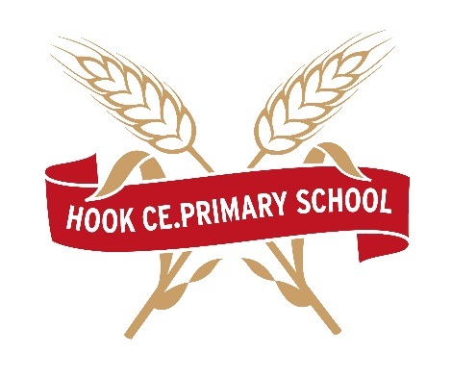

HOOK CE PRIMARY SCHOOL
(part of EDUKOS TRUST)
Vacancy: Part-Time Midday Assistant

Hours: 7.5 hours per week – Monday to Friday 11.45-1.15 term time only

Salary: SCP 2 - £11.59 per hour

In accordance with Children, Family and Adult Services Job Profile and as a member of a team led by the Senior Midday Supervisor under the direction of the Headteacher, to be responsible for ensuring the safety, welfare and good conduct of pupils during the midday break:-

- To maintain order and the safe transfer of pupils to and from the dining area.

To positively encourage good behaviour and table manners and hygiene.

To assist younger pupils where necessary whilst they are taking a meal.

To actively supervise the dining room procedures:-

- carrying of meal to the table
- assisting with the service at the table
- training children in the correct use of cutlery
- clearing and stacking table equipment and serving dishes
- wiping and re-setting tables if necessary
- cleaning up food and water spillages on tables and floors
- cleaning and clearing the dining hall after lunch

To report to the Senior staff in the case of absence due to illness.

To administer first aid in the case of a minor accident acting on the advice of the registered first-aider. Record accidents in the first aid record and report serious accidents to the Headteacher.

Be responsible for organising play activities in the playground or indoors if a wet playtime.

To liaise with the Headteacher and teaching staff of the school in dealing with problems arising from pupil behaviour and any other matters of concern in line with the behaviour policy

- To contribute as a member of a team to the ethos and environment of the school.

- To adhere to need for confidentiality at all times.

- To perform such other duties as reasonably correspond to the general character of the post and are commensurate with its level of responsibility.

Reports to:
The post holder reports to the School Business Manager as a line manager on a day-to-day basis, with the Head Teacher having overall responsibility for this Role.
Safeguarding
Hook CE Primary School is committed to safeguarding and promoting the welfare of children and young people and expects all employees and volunteers to share this commitment. The suitability of all prospective employees will be assessed during the recruitment process in line with this commitment. Two references will be taken up and a DBS check will be needed to be carried out for the successful applicant.

